Linear Programming Assignment

Matthew Vollkommer

1. P is margin. X is radial tires. Y is conventional tires

maximize p = 150x + 100y

2.5x + 2y <= 20000

y <= 8000

x <= 6000

2)

Vertex Lines Through Vertex Value of Objective

(8000,0) 2.5x+2y = 20000; x = 8000 1200000 Maximum

(3200,6000) 2.5x+2y = 20000; y = 6000 1080000

10000

0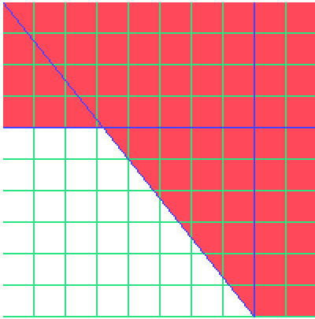10000

3)

